**AMSAT-NA**

**RadFxSat-2 Bakeout Test Procedure**

## Satellite Team Change Log

|  |  |  |  |
| --- | --- | --- | --- |
| **Rev** | **Date** | **Author** | **Change Log** |
| 0 | 3/9/2018 | Robert Davis | Initial rewrite for RadFxSat-2 |

## Satellite Team Responsible Engineer

|  |  |
| --- | --- |
| **Author** | **Contact** |
| Robert Davis | KF4KSS@amsat.org |
| Gerald Buxton | foxse@n0jy.org |

**Purpose:** The purpose of this document is to outline the procedure for thermal vacuum (T-Vac) bakeout of RadFxSat-2. RadFxSat-2 is a 1U CubeSat. Bakeout is performed to remove any potentially outgassing materials from the CubeSat, and to fulfill requirements of L1-VCLS-ICD-21 & L1-VCLS-ICD-22. RadFxSat-2 bakeout will be in a chamber at NTS Boxborough.

1. **Requirements Verified:**

* **L1-VCLS-ICD-21 & L1-VCLS-ICD-22** - Thermal Vacuum Bakeout

The CubeSat shall test to one of the two bakeout profiles outlined in Table 1 and Figure 1. The control temperature is measured at the exterior surface of the CubeSat.

Table : Thermal Vacuum Bakeout Profiles

|  |  |  |  |  |
| --- | --- | --- | --- | --- |
| **Profile** | **Minimum**  **Vacuum Level** | **Minimum Temperature** | **Duration** | **Transition**  **Rate** |
| 1 | < 1x10-4 Torr | 70°C | 3 Hours | < 5°/min |
| 2 | < 1x10-4 Torr | 60°C | 6 Hours | < 5°/min |

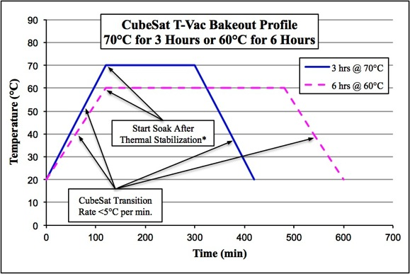

Figure : Thermal Vacuum Bakeout Profile

1. **Test Levels:**

Per the CubeSat ICD requirement, RadFxSat-2 shall then be subject to a thermal vacuum bake out with a minimum temperature of 60ºC and a vacuum level of 10*x*10^-5Torr or better with a dwell time of at least 6 hours. This profile is shown in Figure 2. This lower temperature profile was chosen because the NiCad batteries are temperature limited.

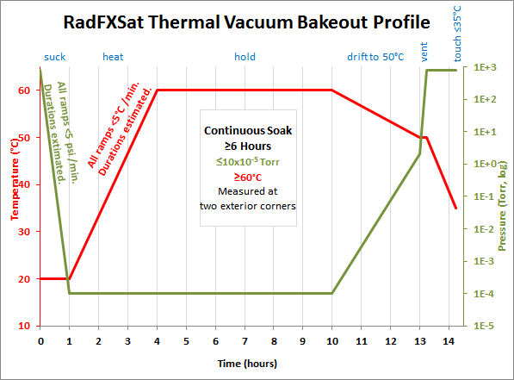

Figure RadFxSat-2 Thermal Vacuum Bakeout Profile

1. **RadFxSat-2**

RadFxSat-2 is a CubeSat, approximately 1.32 kg (2.910 lb) and 112 x 112 x 113 mm (4.4 x 4.4 x 4.4 inches).

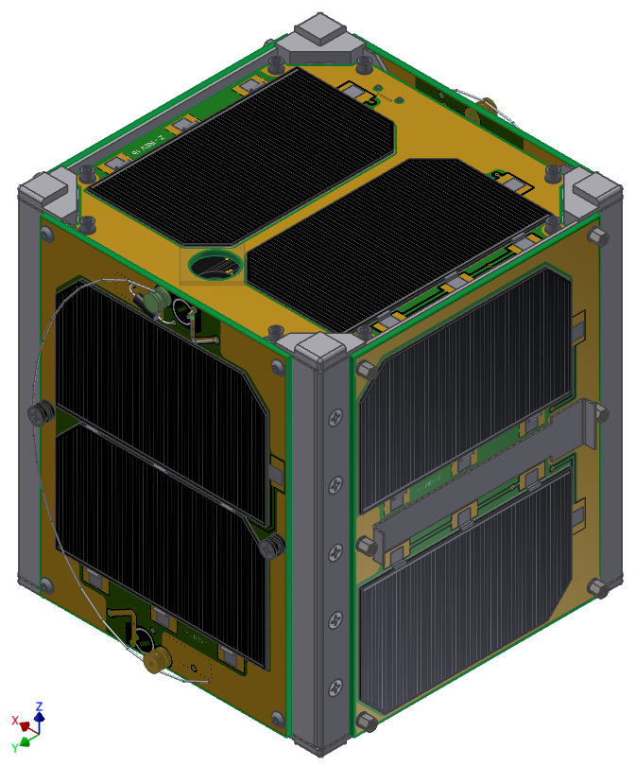

Figure RadFxSat-2 (Stowed as Launch Configuration) +Z,-X,+Y Sides (from top, clockwise)

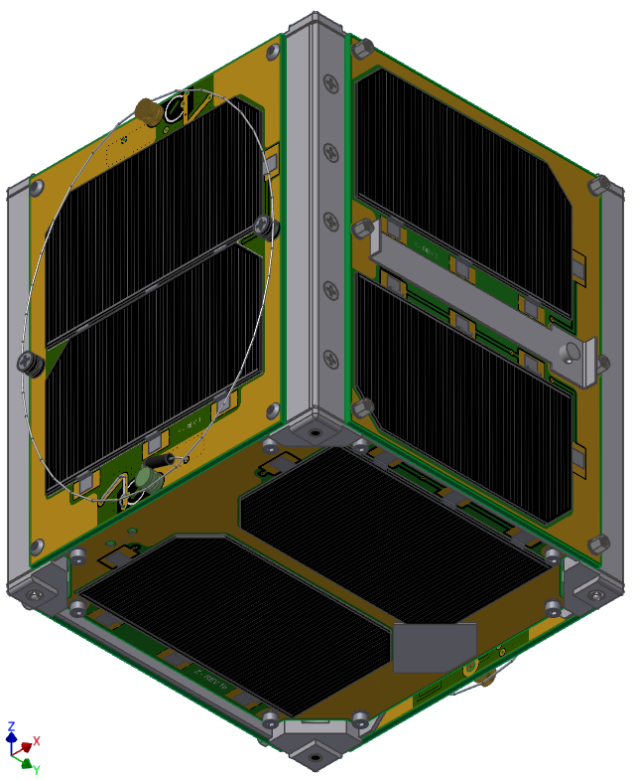

Figure RadFxSat-2 (Stowed as Launch Configuration) -Z,-Y, +X Sides (from bottom, clockwise)

RadFxSat-2 shall be oriented during bakeout as shown in Figure 5. RadFxSat-2 is the fifth CubeSat is AMSAT’s Fox-1 series, and the Bakeout Hat drawing and parts will be reused on RadFxSat-2.

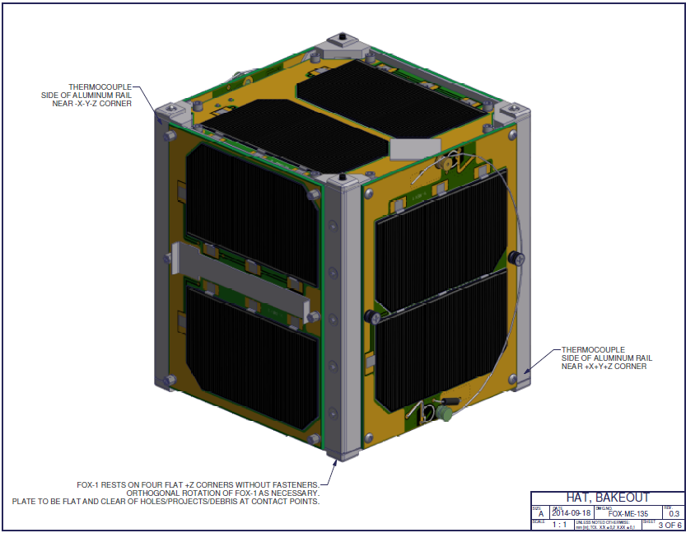

Figure RadFxSat-2 Bakeout Orientation and Thermocouples

1. **RadFxSat-2 Precautions**
2. RadFxSat-2 shall be maintained to Generally Clean (GC) level (freedom from manufacturing residue, dirt, oil, grease, processing debris or other extraneous contamination).
   1. Components & compounds were selected for compliance with low outgassing <1.0 Total Mass Loss (TML) and <0.1 Collected Volatile Condensable Materials (CVCM).
   2. All handling of RadFxSat-2 shall be with powder-free nitrile gloves.
   3. RadFxSat-2 shall be static-dissipative bagged for extended storage.
   4. RadFxSat-2 shall be static-dissipative tented for brief storage.
   5. After completion of Thermal Vacuum Bakeout, RadFxSat-2 “exposure” outside of an ESD bag, or outside of a clean room, shall be very limited. Since AMSAT and NTS Orlando do not have clean rooms, the post-Bakeout Functional Test and Aliveness Test will be completed in an office environment, then bagged. Awaiting delivery, the battery charge will be accomplished inside an ESD bag, when possible.
3. RadFxSat-2 is static sensitive.
   1. All handling shall be while RadFxSat-2 and handler are grounded.
   2. All electrical support equipment shall be grounded.
4. RadFxSat-2 has contact pressure (not atmospheric/vacuum pressure) sensitive surfaces.
   1. Solar Cells crack and shall not be contacted directly.
   2. Solar Panel Covers shall be used whenever practical.
5. RadFxSat-2 has emitted RF.
   1. RadFxSat-2 shall remain powered off unless performing Short Function Test or Aliveness Test.
   2. Short Functional Test may include emitted RF.
   3. Aliveness Test does not include emitted RF.
   4. When emitting, personnel safe distance is defined as no direct contact with either of two coiled wire whip antennas.
   5. When emitting, RadFxSat-2 personnel shall always be present.
6. Unintended power on can damage RadFxSat-2.
   1. RadFxSat-2 shall remain powered off during bakeout, by installation of RBF Pin.
   2. RadFxSat-2 power on can be detected by lit LED, or by audible beeping. RadFxSat-2 does not pose any hazards to itself during the first 50 minutes of power on.
   3. If RadFxSat-2 unintended power on, verify RBF Pin. Suspend testing for further inspection of RadFxSat-2.
7. **Thermal Hat**

AMSAT will provide to NTS the same 4-sided aluminum sheetmetal hat used on Fox-1, as shown in Figure 6, Figure 7, and Figure 8. Its use is optional.

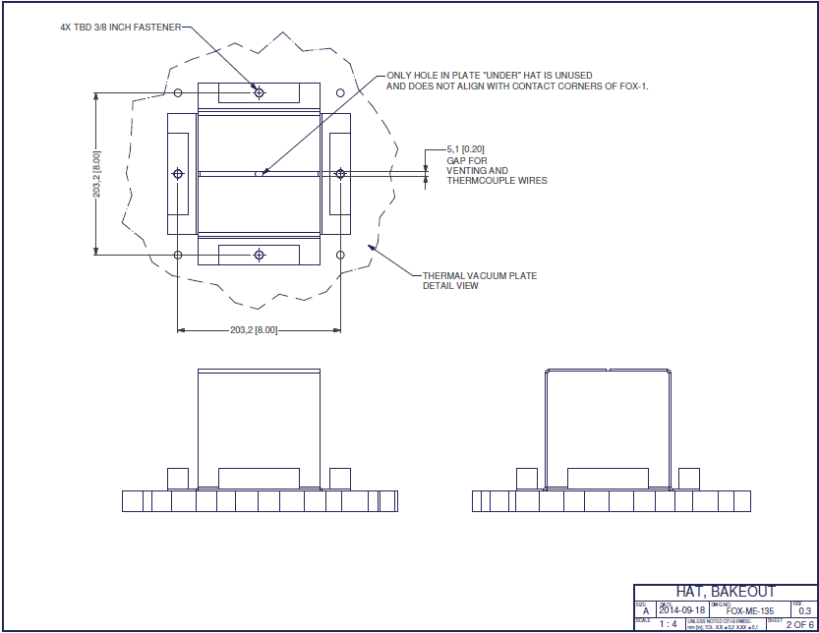

Figure 6 Bakeout Hat, Assembly

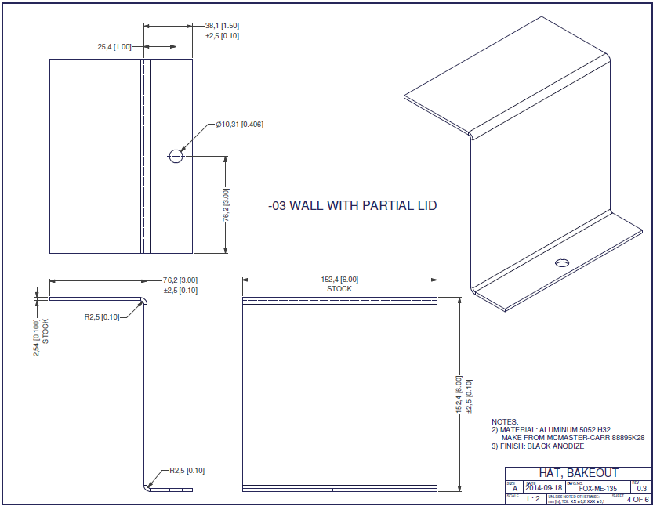

Figure Bakeout Hat, Wall with Partial Lid

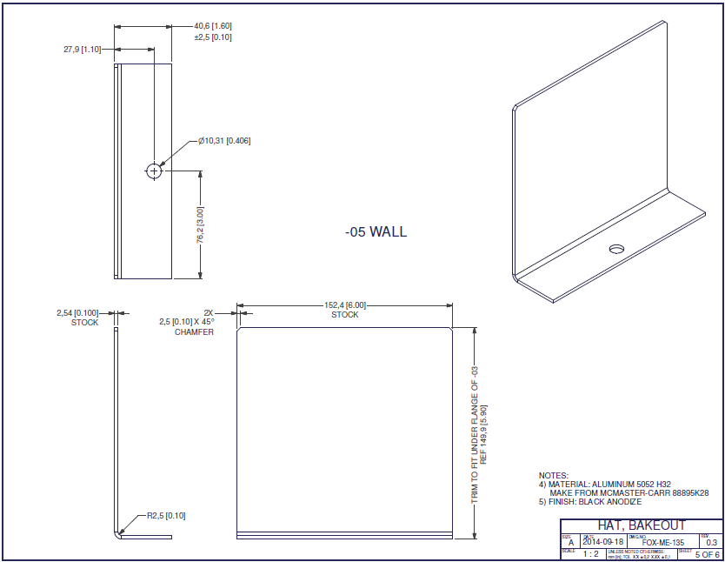

Figure Bakeout Hat, Wall

NTS provides and operates strip heaters located outside the Bakeout Hat.

1. **Thermal Vacuum Hardware:**

Table Hardware

|  |  |
| --- | --- |
| **RadFXSat** | Flight Unit (IHU S/N ?) |
| **Test Chamber** | Thermal Vacuum Chamber at  NTS Boxborough  1146 Massachusetts Ave  Boxborough, MA 01719  (978) 266-1001 |
| **Temperature Sensors** | [Describe type, serial number, quantity] |
| **Gauge(s)** | [Describe gauges and sensors] |
| **Data Acquisition** | [Describe DAQ, software, sampling interval] |

1. **Personnel:**

AMSAT-NA personnel present:

Robert Davis, bakeout test lead, mechanical lead.

Burns Fisher, electrical test.

NTS personnel present:

Chamber test lead:

1. **Bakeout Test Sequence**
   * Ramp to vacuum pressure
   * Ramp to vacuum temperature
   * Dwell for 6 hours
   * Drift to intermediate temperature
   * Vent to ambient pressure
   * Drift to ambient temperature
2. **Pre-Bakeout Procedures**

|  |  |  |  |  |
| --- | --- | --- | --- | --- |
| **PRE-BAKEOUT PROCEDURES** | | | | |
| **Step #** | **Description** | **Time** | **Date** | **Sig.** |
|  | Record IHU S/N __ |  |  |  |
|  | If present, remove Solar Panel Covers |  |  |  |
|  | Concur flight configuration, except RBF Pin is installed. |  |  |  |
|  | If present, remove flag and loop of lacing tape from RBF Pin. Do not remove the RBF Pin. |  |  |  |
|  | Orient RadFxSat-2 on thermal plate as shown in Figure 5. |  |  |  |
|  | Apply a piece of kapton tape, then attach thermocouple to –X-Y-Z corner of RadFxSat-2. |  |  |  |
|  | Take picture of thermocouple location. |  |  |  |
|  | Apply a piece of kapton tape, then attach thermocouple to +X+Y+Z corner of RadFxSat-2. |  |  |  |
|  | Take picture of thermocouple location. |  |  |  |
|  | Optional: Assemble the Bakeout Hat around RadFxSat-2 as shown in Figure 6. |  |  |  |
|  | Optional: Place a thermocouple on the Bakeout Hat. |  |  |  |
|  | Optional: Take picture of thermocouple location. |  |  |  |
|  | Record the locations of each thermocouple in the table below.   |  |  | | --- | --- | | Channel | Location | |  |  | |  |  | |  |  | |  |  | |  |  |  |
|  | Take pictures of the overall test setup. |  |  |  |

**Vacuum Bakeout Test Procedures**

|  |  |  |  |  |
| --- | --- | --- | --- | --- |
| **VACUUM BAKEOUT TEST PROCEDURES** | | | | |
| **Step #** | **Description** | **Time** | **Date** | **Sig.** |
|  | Seal the door. |  |  |  |
|  | Begin recording data in [Computer program used]  Note: Sample rate of 5 mins for temp, 10 mins for pressure or better is recommended. Be sure to record the start and end times. |  |  |  |
|  | Pull vacuum in the chamber to at least 10E-5 Torr. The chamber must stay below this vacuum level for the entirety of the test plateau. |  |  |  |
|  | Once the pressure level is achieved, begin to heat the chamber to 65ºC [negotiable] while ensuring that the heating rate is less than 5ºC/minutes. Temperature is 5ºC greater than minimum temperature to create buffer above minimum temperature. |  |  |  |
|  | Begin the soak once the thermocouples on RadFxSat-2 read greater than 60ºC. Limit overshoot. Likely target 62ºC. |  |  |  |
|  | Soak RadFxSat-2 for 6 hours, ensuring that the thermocouples on RadFxSat-2 read at least 60ºC and pressure reads at least 10E-5 Torr, for the entirety of the soak. There will need to be at least one people watching the chamber at all times. |  |  |  |
|  | RadFxSat-2 has soaked for a minimum of 6 hours at a minimum temperature of 60ºC and maximum pressure of 10E-5 Torr. |  |  |  |
|  | Cut heater power. Allow the temperature in the chamber to drift to 50ºC. |  |  |  |
|  | Bring the chamber back to atmospheric pressure. |  |  |  |
|  | Allow the temperature in the chamber to drift to at least 35ºC (minimum touch temperature). |  |  |  |
|  | Stop recording temperature data. Saved data filename  __ |  |  |  |

1. **Post-Vacuum Bakeout Procedures**

|  |  |  |  |  |
| --- | --- | --- | --- | --- |
| **POST-VACUUM BAKEOUT PROCEDURES** | | | | |
| **Step #** | **Description** | **Time** | **Date** | **Sig.** |
|  | Open the chamber door. |  |  |  |
|  | Optional: Remove Bakeout Hat, removing thermocouples as required. |  |  |  |
|  | Remove thermocouples from RadFxSat-2 . |  |  |  |
|  | Remove RadFxSat-2 from chamber and place in static dissipative bag. Note: Volatiles have now been baked off RadFxSat-2 , so be sure to keep as clean as possible. |  |  |  |

1. **Post-Vacuum Bakeout Short Functional and Aliveness Tests**

|  |  |  |  |  |
| --- | --- | --- | --- | --- |
| **POST-VACUUM BAKEOUT SHORT FUNCTIONAL AND ALIVENESS TESTS** | | | | |
| **Step #** | **Description** | **Time** | **Date** | **Sig.** |
|  | Record IHU S/N __ |  |  |  |
|  | Concur flight configuration, except RBF Pin is installed and Solar Panel Covers are optional. |  |  |  |
|  | Perform Short Functional Test. |  |  |  |
|  | Perform Aliveness Test. |  |  |  |
|  | Verify RBF Pin is installed. |  |  |  |
|  | Optionally, install Solar Panel Covers. |  |  |  |
|  | Optionally, place in static dissipative bag for storage/shipping. See Section 4 RadFxSat-2 Precautions, items 1.c-e. |  |  |  |